Lab#04
Implementation of various operators in java
Objective
To get familiarity with the various operators in java.
Lab Goals
To provide working insight into the usage of various operators in java programming:
a. Demonstrate the implementation of various operators.
b. Explore Arithmetic, Assignment, Relation, Logical, Ternary and Bitwise operators in Java.
c. Explore Auto-increment and Auto-decrement Operators
Introduction to operators
In Java, operators are symbols used to perform operations on variables and values. They are
categorized into different types based on the operations they perform, such as arithmetic, relational, logical, bitwise, assignment, and more.
Basic Arithmetic Operators
These operators are used to perform basic arithmetic operations like addition, subtraction,
multiplication, division, and modulus.
• + (Addition)
• - (Subtraction)
• * (Multiplication)
• / (Division)
• % (Modulus)
Example
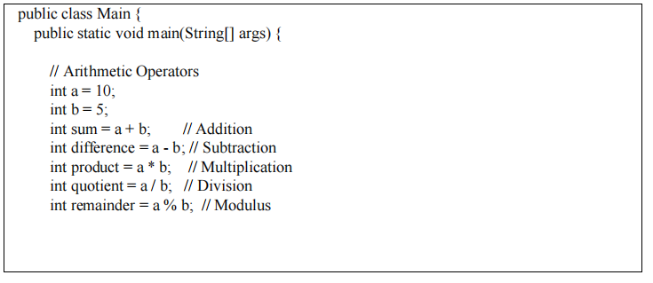

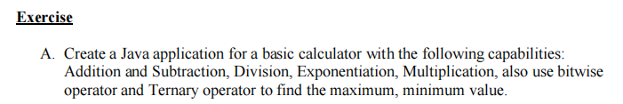
Program:
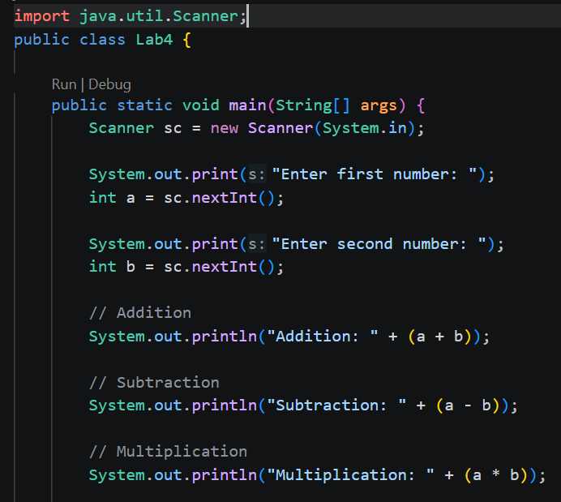
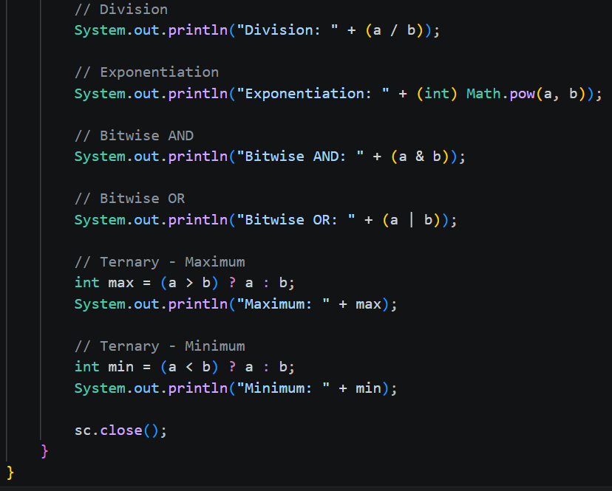

Output:
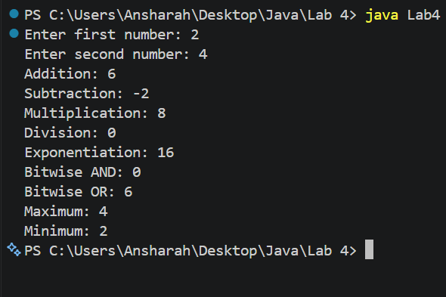
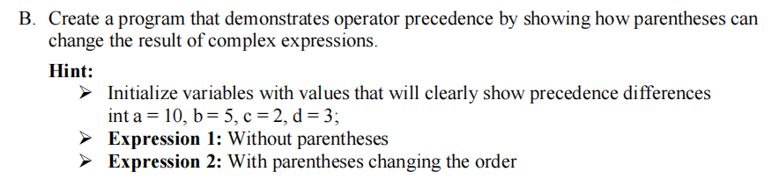
Program:
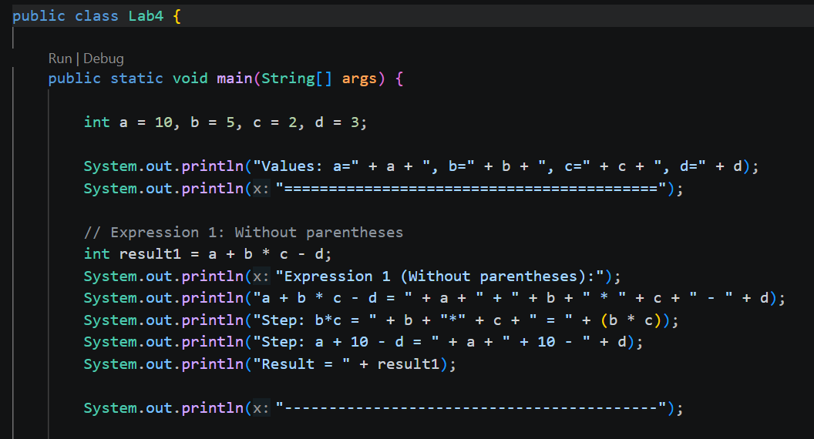
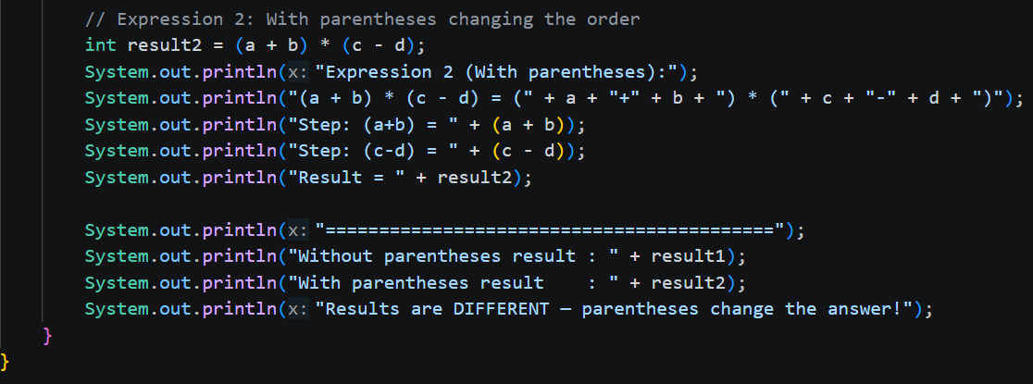

Output:
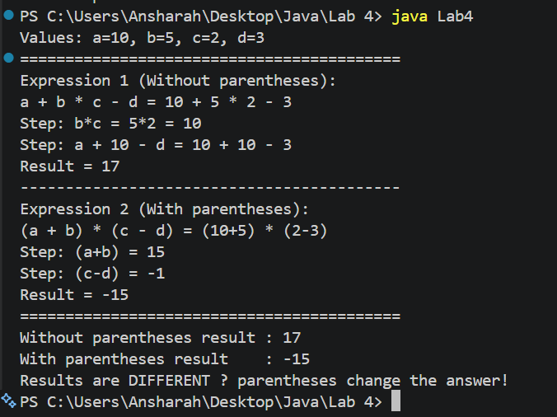
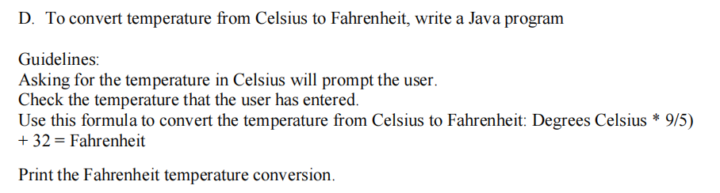
Program:
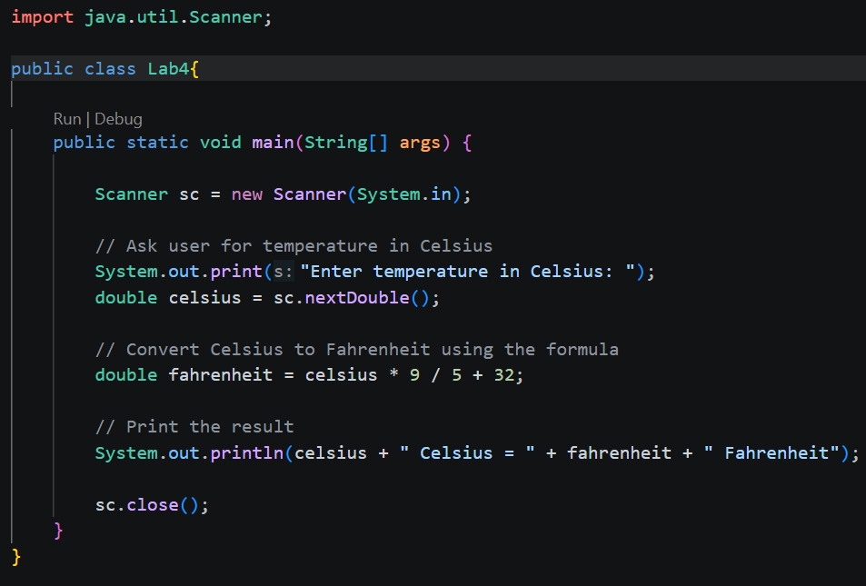
Output:
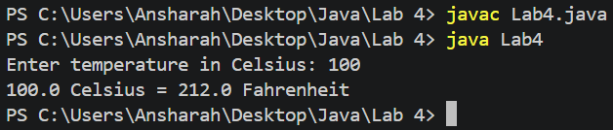

Program:
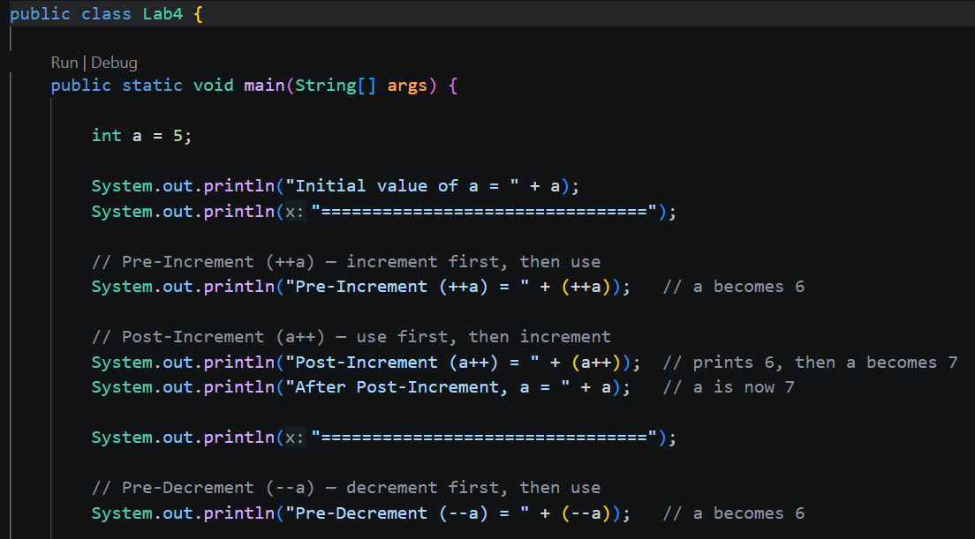
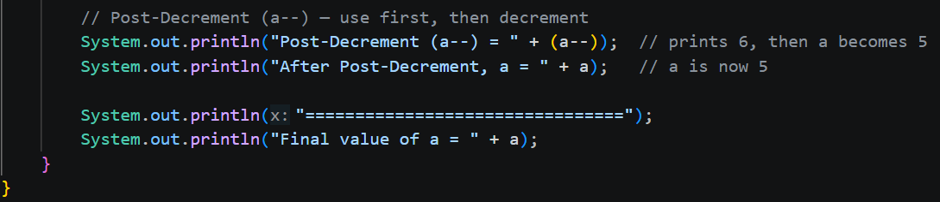
Output:
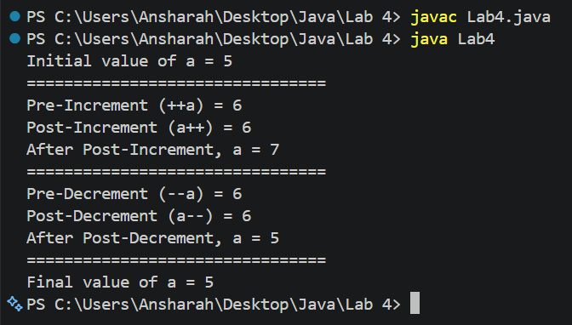

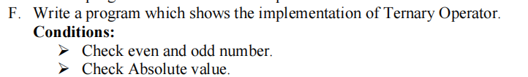
Program:
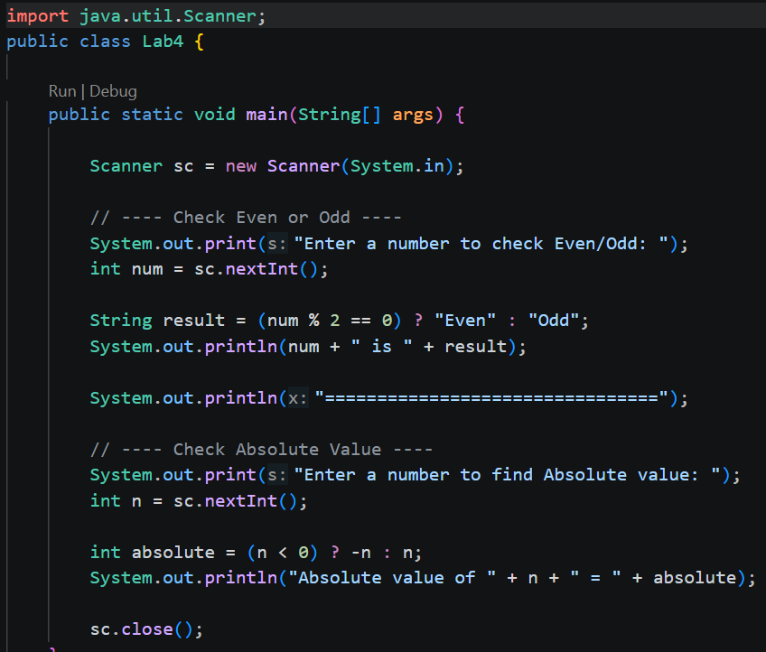
Output:
